**Presented by:**

**Eran Kamil 311246649**

**Tomer Picker 312500937**

**Classes:**

**Ex03.GarageLogic:**

**"Public class Vehicle"** - A class representing a general vehicle shield. The class holds data that is common to all types of vehicles in the garage. Each of the specific vehicles is inherited from this class. Such as - license plate.

**"Internal class Car"** - A class representing a specific type of vehicle named a car. The class inherits data from Vehicle, holds more data relevant to the specific vehicle - car. Such as - number of doors.

**"Internal class MotorCycle"** - A class representing a specific type of vehicle named a motor cycle. The class inherits data from Vehicle, holds more data relevant to the specific vehicle - motor cycle. Such as - license type.

**"Internal class Trunk"** - A class representing a specific type of vehicle named a trunk. The class inherits data from Vehicle, holds more data relevant to the specific vehicle - trunk. Such as - cargo volume.

**"Internal class EnergySource"** - A class that represents the engine type of the vehicle. Possible engine types are gasoline engine and electric motor. The class is a member of the vehicle class because it’s a shared feature to all vehicle’s types. The class holds data that common to both of the engine types.

**"Internal class FuelEnergySource"** - A class representing a specific type of engine - fuel, inherits from "EnergySource" class. The class holds data relevant to vehicles using a fuel engine. Such as - fuel type(Soler and etc.)

**"Internal class ElectricEnergySource"** - A class representing a specific type of engine - electric, inherits from "EnergySource" class. The class holds data relevant to vehicles using an electric engine. Such as - battery amount.

**"public class CustomerCard"** - Class that holds all the data the needed for the garage on the specific customer. Such as - owner's vehicle name.

**"public class Garage"** - Managing the garage and  it's customers. Holds book of customers, responsible for doing the various actions possible in the garage. Such as - charge electric car.

**"public static VehicleCreator"** - The only responsibility of this class is to create a new vehicle.

**"public class ValueOutOfRange"** - The class inherits from exception. A class that will throw an exception when incorrect input is received in terms of value range.

**Ex03.Ui.exe:**

"internal class GarageUi" - A class representing all the user interface.

"internal class Program" - Entry point of the specific dll.

**Enums:**

**"public enum eCarState"** - Enum class representing the various possible situation in terms of the garage. Such as - paid.

**"public enum eEnergyType"** - Enum class representing engine vehicle type - gasoline/electric.

**"public enum eFuelType"** - Enum class representing the various possible fuel type exists.

**"public enum eHasHazardousMaterial"** - Enum class representing if the trunk carried Hazardous material.

**"public enum eTrunkInfo"** - Enum class representing all the data relevant to trunk, for passing info about the trunk.

**"public enum eType"** - Enum class representing what kind of vehicle - car/trunk

**"public enum eVehicleInfo"** - Enum class representing all the data relevant to vehicle, for passing info about each vehicle.

**"public enum eVehicleWheels"** - Enum class representing info about number of wheels in accordance to the vehicle type.

**"public enum eColor"** - Enum class representing possible car colors.

**"public enum eNumOfDoors"** - Enum class representing how many doors the car has.

**"public enum eLicenseType"** - Enum class representing license type needed for riding the motor cycle.

**"public enum eCarInfo"** - Enum class representing all the data relevant to car, for passing info about the car.

**"public enum eMotorCycleInfo"** - Enum class representing all the data relevant to motorcycle, for passing info about the motorcycle.

**Class EnergySource**

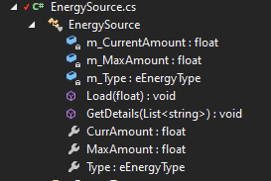



**Class ElectricEnergySource**

**Class FuelEnergySource**



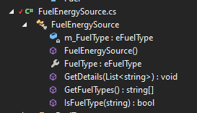

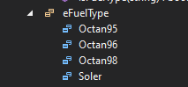

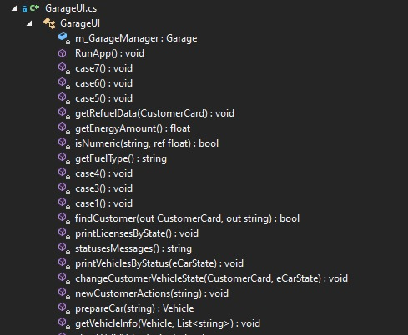

**Class VehicleCreator**

**Class GarageUI**

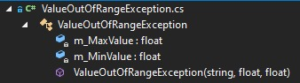

**Class Garage**

**Class ValueOutOfRangeException**

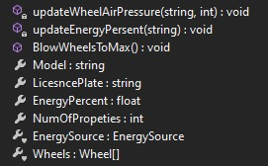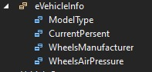

**Class MotorCycle**

**Class Car**

**Class Trunk**

**Class Vehicle**

**Class Wheel (nested in Vehicle)**